Latest Round-ups:
Season 2019/20
#8
Midweek Action: Sherborne’s run in the FA Vase came to an end on Tuesday evening after they were defeated 1-0 in their replay away at Petersfield Town. The only goal of the game at Love Lane came just before half-time, with Harry Bedford scoring for the home side. The Les Phillips Cup also got underway during the week, with eight preliminary round ties taking place. Odd Down responded well to their mauling three days earlier in the league, beating Lebeq United 3-0 in Bath. Goals from Reeko Best and Jake Hutchings handed the hosts a strong lead at the break, with Josh Cann then teeing up Anthony Conradi who slotted home their third. Four goals before the break from Exmouth Town saw them progress, thanks to a 4-1 win away at Almondsbury. After Aaron Denny’s deflected effort had handed the Devon side an early advantage, Adam Bilcock, Scott Merritt and Karl Rickard then scored in the space of 14 minutes to hand the visitors an unassailable lead. Ryan Bath’s goal ten minutes from time saw Brislington squeeze past Bishop Sutton by one goal to nil, while Kameron Andrews and Anele Ncube helped Street win 2-0 away at Wincanton. On Wednesday evening, Hengrove secured a much needed boost by beating Bristol Telephones 5-1 at Paprika Park. There were five different goalscorers for Grove during their victory, with Mickey Parsons, Danny Lock, Luke Crewe, Jack Jones and Ellis McDonald all finding the back of the net. Roman Glass St George couldn’t quite replicate the 8-0 victory they recorded over Wellington 11 days earlier, but they did ease their way through to the next round, winning 3-0 at the Playing Field. Troy Simpson fired home two fantastic strikes to give the visitors control of the game, before George Box wrapped up the victory 13 minutes from time. Jack Crago’s remarkable cup scoring run continued away at Cadbury Heath, with Tavistock’s main man scoring a late winner from the spot to cap their 2-1 victory at Springfield. There was also a 2-1 win for Portishead Town away at Oldland Abbotonians, with Mitch Osmond and Jack Sell striking for the Posset.
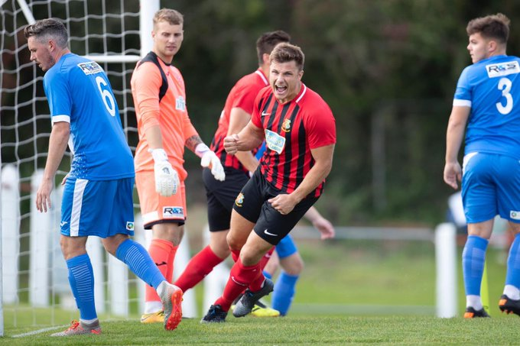
FA Cup: Tavistock’s terrific run in this season’s FA Cup will continue after they claimed a 4-0 win over Highworth Town at Langsford Park. The Southern League outfit had knocked Exmouth out in the previous round, but they were no match for the Lambs, who were handed an early lead by Dan Evans (pictured, right). The hosts doubled their advantage in the early stages of the second half through Tallan Burns, before cup hero Jack Crago struck his 15th of the season from the spot late on. There was still time left on the clock for Luke Cloke to add a late fourth for Tavistock, who will face a third qualifying round tie in two weeks’ time.
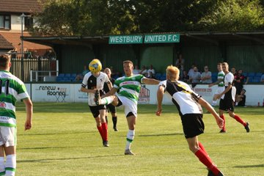
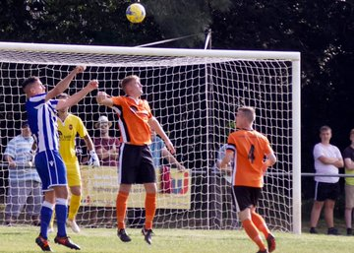
Premier Division: Keynsham Town have drawn 3-3 for the second week in a row, this time after surging back from three goals down to tie with early pacesetters Plymouth Parkway. After 37 goalless minutes, Parkway took the lead through Billy Palfrey following a defensive error, with Adam Carter then doubling their advantage from the spot five minutes later. When Carter struck for the second time at the beginning of the second half, Parkway looked set to maintain their winning start at Bolitho Park, but last year’s First Division champions had other ideas. Goals from Tom Knighton and Cam Ricketts got Keynsham back into the contest, and then with ten minutes left on the clock, Craig Wilson fired a low shot in to the back of the net to complete a remarkable comeback. Shepton Mallet remain unbeaten in the league this season, after claiming a 5-2 victory away at Westbury United. A strike from Westbury’s Ricky Hulbert cancelled out Conrad Peck’s 16th minute opener, before new signing Cameron Allen restored Shepton’s lead in first half stoppage-time. The away side added to their advantage after the break, with Jack Fillingham scoring either side of an Aaron Seviour strike, before United claimed a late consolation through Joe Stradling. In another high-scoring affair, Clevedon overturned a half-time deficit to defeat Bridport 4-3 at the Hand Stadium. After falling behind in the early stages, Town got back on level terms thanks to an effort from Lucas Vowles, before Lewis Clarke struck from the spot to put the visitors ahead once more. Excellent play from Zach Drew teed up Jay Murray who claimed Clevedon’s second equaliser of the afternoon, with Vowles then putting them ahead for the first time midway through the second half. It was then Bridport’s turn to produce a fightback of their own, and they did just that with Joel Hewitt levelling affairs, but then with 12 minutes remaining, George King slotted home to help Clevedon rise to third. Bridgwater enjoyed their trip away to Wellington, with prolific frontman Jack Taylor scoring twice in a 3-0 victory. Stewart Bowker also grabbed a brace during Buckland Athletic’s 3-1 win away at Brislington, with Matt Dawson also on target for the Devon side. Exmouth Town’s first league encounter of the month ended in victory, with Ben Steer playing a major role in their 4-0 triumph away at Cribbs. Steer opened the scoring after quarter of an hour, before adding a second half double to complete his hat-trick, with Ace High also on the scoresheet for the visitors.
Goalmouth action from Bridgwater Town’s 3-0 victory away at Wellington.
Action from Shepton Mallet’s 5-2 win away at Westbury, courtesy of Martin Pearce.
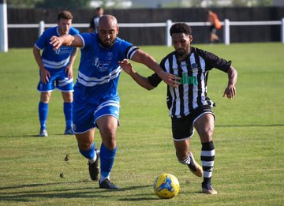
Street came out on top in a dramatic affair away at Bradford Town, scoring an injury-time winner to prevail by three goals to two. Ollie Pearson, Sam Strange and Leighton Thomas all struck in victory for the away side, with Tyson Pollard and Lee Davidson scoring at the beginning and end of the first half for Bradford. The hosts came agonisingly close to claiming a dramatic late equaliser, but Pollard’s headed effort ricocheted back off the crossbar, meaning Street hung on for all three points. Hallen picked up their first home win of the season, with Isaac Reid and Kyle Thomas helping them beat Chipping Sodbury Town 2-0, while Cadbury Heath battled out a 0-0 draw with Odd Down.
Players from Hallen & Chipping Sodbury battle for possession during their Premier Division contest. Image courtesy of James Healey.

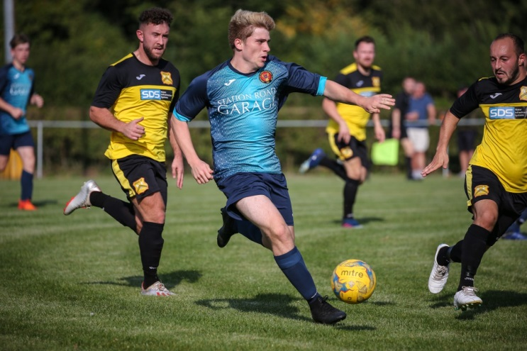
First Division: Bishop Sutton got the First Division action underway on Friday evening with a comfortable 4-0 victory over Radstock Town. In front of a three-figure crowd at Lakeview, two goals from Adam Mahdi gave the home side a two-goal lead after 25 minutes. Kyle Tooze then added a third for Sutton before the interval, before Frankie Carr struck seven minutes from time to wrap up their first three points since early-August. Corsham Town handed Cheddar their first league defeat of the season, beating the Cheesemen 3-2 thanks to a late winner. After 60 goalless minutes, Ricky Bennett’s whipped free-kick put the hosts ahead, before Ash Alchin and Josh Hard struck to turn the game in Corsham’s favour. Cheddar hit back soon after falling behind thanks to a low driven effort from Callum Laird, but it was Town who had the last word with Hard setting up strike partner Josh Bright who fired home to cap a dramatic final half-hour. Wincanton’s impressive start continued at home to Wells, with goals either side of the interval from Harry Carter and Dan Wise firing them to a 2-0 victory. It is still Oldland Abbotonians who sit top at this early stage in the season, with their latest point coming on the back of a goalless draw away at Ashton & Backwell United.
Corsham Town on the attack during their 3-2 victory away at Cheddar at Bowdens Park. Image courtesy of John Cuthbertson.

Sherborne Town were one of the big movers on Saturday, beating Portishead 3-2 at Raleigh Grove. Josh Williams and man of the match Haydn Hodges each struck for the Zebras, with Dan Newens then scoring the winning goal to give the hosts their fourth league win of the campaign. A wild spell at the end of the first half cost Welton Rovers dearly, with their fightback falling just short away at Almondsbury who prevailed by three goals to two. Having fallen behind to Alex Bisp’s long-range curler on the half-hour, Welton then switched off in first half stoppage time, conceding twice to Greg Parr and Bisp to trail by three at the break. Goals from Will Hunter and Joe Garland provided Welton with a foothold in the contest, but they had left themselves too much work to do and Almondsbury hung on for all three points. Ryan Brereton’s double led Bishops Lydeard to a 2-1 win at home to bottom-side Bristol Telephones, while at Nursteed Road, Luke Enderby and Sean McKeon were each on target during Devizes’ 3-0 victory over Lebeq United. Hengrove Athletic’s recent upturn in form continued away at Warminster Town, where goals in either half from Mickey Parsons and Regan Burton saw them register a 2-1 victory. In one of the highly-anticipated clashes on Saturday afternoon, defences were on top in Bristol where Longwell Green Sports drew 0-0 with Calne Town.

August Teams of the Month
Director Sue Merrill presents the Premier Division award to Bradford Town manager Wayne Thorne in the image on the left.
On the right, Sherborne Town skipper George Mapletoft accepts the First Division award from Western League Director Colin Goodland.

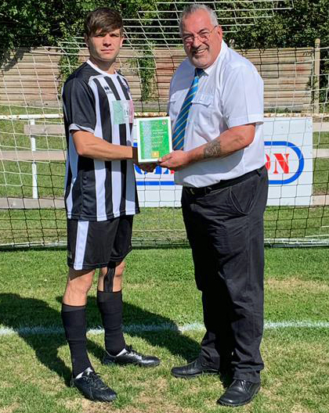
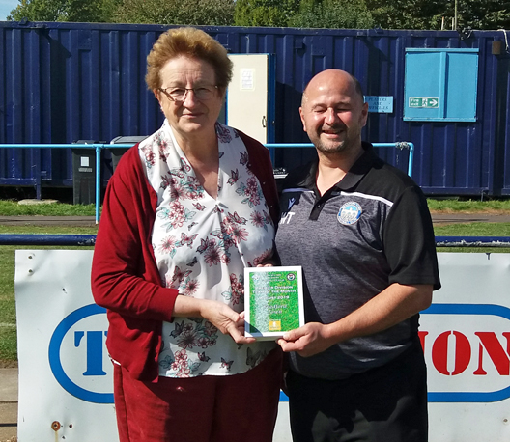

Western League Statistical Leaders

PREMIER DIVISION LEADING GOAL SCORERS (League only):
Adam Carter (Plymouth Parkway) – 13
Josh Egan (Bitton) – 8
Lucas Vowles (Clevedon Town) – 8
Jack Fillingham (Shepton Mallet) – 7
Gary Higdon (Bradford Town) – 5
Jayden Nielson (Brislington) – 5
Liam Prynn (Tavistock) – 5

PREMIER DIVISION TOP ATTENDANCES:
Plymouth Parkway 1 Exmouth Town 0, Wednesday 21st August 2019 - 308
Plymouth Parkway 7 Cadbury Heath 1, Saturday 3rd August 2019 – 303
Bridgwater Town 1 Cribbs 1, Tuesday 6th August 2019 - 237

FIRST DIVISION LEADING GOAL SCORERS (League only):
Stuart Windsor (Calne Town) – 8
Adam Wright (Cheddar) – 7
James Rustell (Radstock Town) – 7
Toby Cole (Wincanton Town) – 6
Harry Foster (Wells City) – 5

FIRST DIVISION TOP ATTENDANCES:
Warminster Town 0 Welton Rovers 1, Saturday August 3rd – 174
LEADING SCORERS IN ALL COMPETITIONS:
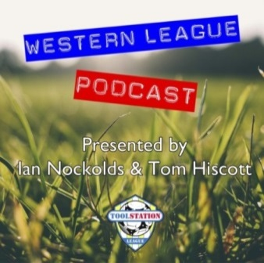
Jack Crago (Tavistock) - 15
Adam Carter (Plymouth Parkway) – 13
Jack Fillingham (Shepton Mallet) – 10
Lucas Vowles (Clevedon Town) – 9
Gary Higdon (Bradford Town) – 9
Stuart Windsor (Calne Town) – 9
Harry Foster (Wells City) – 9
Josh Egan (Bitton) - 8
Adam Wright (Cheddar) – 7
James Rustell (Radstock Town) – 7
Be sure to check out the latest podcast, where Ian, Tom & guests recap all the latest news and results from around the Western League. To follow along all season, each broadcast will be available at the following link: http://www.toolstationleague.com/podcasts.php

*All goalscoring stats via
Full-Time FA website

Latest Results
Tuesday 17th September 2019
FA Vase – 2nd Qualifying Round Replay
Petersfield Town 1-0 Sherborne Town
Les Phillips Cup – Preliminary Round
Almondsbury 1-4 Exmouth Town 48
Brislington 1-0 Bishop Sutton 69
Odd Down 3-0 Lebeq United 45
Wincanton Town 0-2 Street 89
Wednesday 18th September 2019
Les Phillips Cup – Preliminary Round
Cadbury Heath 1-2 Tavistock 48
Hengrove Athletic 5-1 Bristol Telephones 48
Oldland Abbotonians 1-2 Portishead Town 30
Wellington 0-3 Roman Glass St George 65
Friday 20th September 2019
First Division
Bishop Sutton 4-0 Radstock Town 115
Saturday 21st September 2019
FA Cup – Second Qualifying Round
Tavistock 4-0 Highworth Town 189
Premier Division
Bradford Town 2-3 Street 117
Brislington 1-3 Buckland Athletic 65
Cadbury Heath 0-0 Odd Down 42
Clevedon Town 4-3 Bridport 77
Cribbs 0-4 Exmouth Town 64
Hallen 2-0 Chipping Sodbury Town 60
Plymouth Parkway 3-3 Keynsham Town 149
Wellington 0-3 Bridgwater Town 152
Westbury United 2-5 Shepton Mallet 85
First Division
Almondsbury 3-2 Welton Rovers 39
Ashton & Backwell United 0-0 Oldland Abbotonians 53
Bishops Lydeard 2-1 Bristol Telephones
Cheddar 2-3 Corsham Town 65
Devizes Town 3-0 Lebeq United 108
Longwell Green Sports 0-0 Calne Town 72
Sherborne Town 3-2 Portishead Town 73
Warminster Town 1-2 Hengrove Athletic 102
Wincanton Town 2-0 Wells City 72

Upcoming Fixtures
Tuesday 24th September 2019
Premier Division
Odd Down vs Bradford Town 19:30KO
Wednesday 25th September 2019
Premier Division
Cadbury Heath vs Bridgwater Town 19:30KO
Saturday 28th September 2019 (KICK OFF AT 3.00PM UNLESS NOTED)
Premier Division
Bitton vs Plymouth Parkway
Bridgwater Town vs Roman Glass St George
Buckland Athletic vs Clevedon Town
Chipping Sodbury Town vs Bridport
Cribbs vs Odd Down
Exmouth Town vs Cadbury Heath
Keynsham Town vs Tavistock
Shepton Mallet vs Brislington
Street vs Hallen
Westbury United vs Wellington
First Division
Bishop Sutton vs Almondsbury
Bishops Lydeard vs Calne Town
Bristol Telephones vs Devizes Town
Corsham Town vs Wells City
Hengrove Athletic vs Ashton & Backwell United
Lebeq United vs Wincanton Town 15:15KO
Oldland Abbotonians vs Cheddar
Radstock Town vs Longwell Green Sports
Sherborne Town vs Warminster Town
Welton Rovers vs Portishead Town
Les Phillips Cup First Round Draw
- Ashton & Backwell United vs Bitton
- Bishops Lydeard vs Keynsham Town
- Bridgwater Town vs Odd Down
- Brislington vs Bradford Town
- Buckland Athletic vs Cheddar
- Clevedon Town vs Chipping Sodbury Town
- Corsham Town vs Wells City
- Cribbs vs Welton Rovers
- Devizes Town vs Hallen
- Exmouth Town vs Plymouth Parkway
- Hengrove Athletic vs Shepton Mallet
- Roman Glass St George vs Bridport
- Sherborne Town or Radstock Town vs Street
- Tavistock vs Calne Town
- Warminster Town vs Portishead Town
- Westbury United vs Longwell Green Sports

League Tables
Premier Division
 |  | P | W | D | L | F | A | GD | PTS
1 | Plymouth Parkway | 7 | 5 | 1 | 1 | 29 | 6 | 23 | 16
2 | Bridgwater Town | 6 | 4 | 1 | 1 | 21 | 8 | 13 | 13
3 | Clevedon Town | 6 | 4 | 1 | 1 | 17 | 11 | 6 | 13
4 | Bitton | 5 | 4 | 0 | 1 | 21 | 4 | 17 | 12
5 | Bradford Town | 5 | 4 | 0 | 1 | 16 | 9 | 7 | 12
6 | Brislington | 7 | 4 | 0 | 3 | 12 | 16 | -4 | 12
7 | Shepton Mallet | 4 | 3 | 1 | 0 | 13 | 6 | 7 | 10
8 | Odd Down | 8 | 3 | 1 | 4 | 12 | 20 | -8 | 10
9 | Exmouth Town | 4 | 3 | 0 | 1 | 9 | 2 | 7 | 9
10 | Street | 5 | 3 | 0 | 2 | 11 | 11 | 0 | 9
11 | Hallen | 5 | 3 | 0 | 2 | 12 | 13 | -1 | 9
12 | Buckland Athletic | 6 | 3 | 0 | 3 | 10 | 13 | -3 | 9
13 | Keynsham Town | 7 | 2 | 2 | 3 | 16 | 17 | -1 | 8
14 | Westbury United | 6 | 2 | 1 | 3 | 11 | 14 | -3 | 7
15 | Cadbury Heath | 6 | 2 | 1 | 3 | 8 | 14 | -6 | 7
16 | Tavistock | 3 | 2 | 0 | 1 | 9 | 5 | 4 | 6
17 | Cribbs | 7 | 1 | 1 | 5 | 5 | 18 | -13 | 4
18 | Bridport | 8 | 1 | 1 | 6 | 12 | 26 | -14 | 4
19 | Chipping Sodbury Town | 8 | 1 | 1 | 6 | 7 | 27 | -20 | 4
20 | Roman Glass St George | 4 | 1 | 0 | 3 | 11 | 6 | 5 | 3
21 | Wellington | 7 | 1 | 0 | 6 | 6 | 22 | -16 | 3

First Division
 |  | P | W | D | L | F | A | GD | PTS
1 | Oldland Abbotonians | 8 | 4 | 3 | 1 | 8 | 7 | 1 | 15
2 | Wincanton Town | 6 | 4 | 2 | 0 | 17 | 7 | 10 | 14
3 | Calne Town | 7 | 4 | 1 | 2 | 13 | 5 | 8 | 13
4 | Cheddar | 5 | 4 | 0 | 1 | 14 | 8 | 6 | 12
5 | Wells City | 6 | 4 | 0 | 2 | 14 | 11 | 3 | 12
6 | Sherborne Town | 6 | 4 | 0 | 2 | 13 | 11 | 2 | 12
7 | Ashton & Backwell United | 6 | 3 | 2 | 1 | 9 | 7 | 2 | 11
8 | Longwell Green Sports | 6 | 3 | 1 | 2 | 11 | 8 | 3 | 10
9 | Bishops Lydeard | 6 | 3 | 0 | 3 | 15 | 10 | 5 | 9
10 | Radstock Town | 6 | 3 | 0 | 3 | 15 | 13 | 2 | 9
11 | Portishead Town | 6 | 3 | 0 | 3 | 14 | 12 | 2 | 9
12 | Corsham Town | 7 | 3 | 0 | 4 | 13 | 20 | -7 | 9
13 | Almondsbury | 6 | 2 | 1 | 3 | 7 | 8 | -1 | 7
14 | Devizes Town | 5 | 2 | 0 | 3 | 13 | 12 | 1 | 6
15 | Warminster Town | 6 | 2 | 0 | 4 | 12 | 11 | 1 | 6
16 | Bishop Sutton | 6 | 2 | 0 | 4 | 9 | 10 | -1 | 6
17 | Welton Rovers | 5 | 2 | 0 | 3 | 5 | 8 | -3 | 6
18 | Lebeq United | 6 | 2 | 0 | 4 | 9 | 16 | -7 | 6
19 | Hengrove Athletic | 7 | 1 | 2 | 4 | 4 | 22 | -18 | 5
20 | Bristol Telephones | 6 | 0 | 0 | 6 | 6 | 15 | -9 | 0

